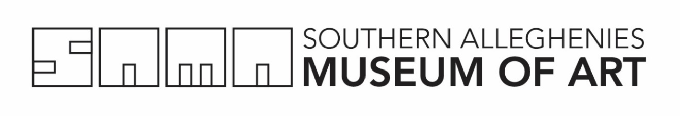

Residency Budget Worksheet  Museum Healthcare Partnership | Southern Alleghenies Museum of Art  P.O. Box 9, Loretto, PA 15940  p: 724-238-6015 / f: 724-238-6281  kmiller@sama-art.org

Please type or print clearly in ink:

Eligible Expenses are residency expenses that are eligible for up to a 50% matching grant from SAMA. This includes artist fees and mileage. Additional funding may be granted for materials. Please contact SAMA Education Coordinator to discuss the availability of supplies.

I. Planning & Residency Days

Number of Planning Days (maximum of 3 days/20 day residency, maximum of 1 day/10 day residency (A)___________

Number of Residency/Teaching Days (min. of 17 days for a 20 day residency) (B)___________

Total Number of Days (A+B) (C)___________

Artist Fee per Day (min. $200, artist/host are free to negotiate a higher fee) (D)$__________

Total Artist Fees [(C) X (D)] (E)$__________

II. Travel Expenses

Mileage: (only applicable when artist travels 50 miles or more, one way per day, to residency site)*

Miles per Day (from mile one, if over 50 miles) (F) __________

Total Mileage [(C) X (F) X $0.56] (G)$__________

III. Total Eligible Expenses

(E + G) (H)$__________

IV. Funding Requested

Amount Requested from SAMA (cannot be more than half of Total Eligible Expenses) (I)$__________

Amount of Matching Funds(must be at least half of Total Eligible Expenses) (J)$__________

Administration Fee (10% of E) (K) $_________

Total Funds paid by Organization (J+K) (L) $_________

Source of Matching Funds: ______________________________________________

Matching Funds are: □ Secured □ Pending

