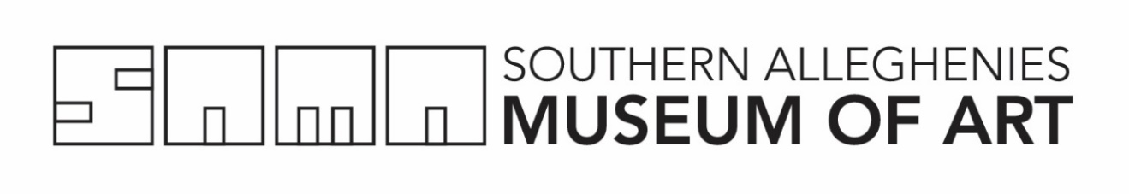

Residency Request Form  Museum Healthcare Partnership | Southern Alleghenies Museum of Art  P.O. Box 9, Loretto, PA 15940  p: 724-238-6015 / f: 724-238-6281  kmiller@sama-art.org

Please include the Residency Request Form, Budget Worksheet, and Narrative Description with your request.

Application Form: Please complete ALL fields by type or print clearly in ink

Organization:_____________________________________________________________________________________

House #: Senate #: __________________ __**Federal District #: ___________________

Address: ___________________________________________________________________________________________

City: ______________________________State: ______________________________County: _______________________

***Full Zip: ________________________________ Phone: ___________________________________________________

Email: ______________________________________________________________________________________________

Site Coordinator: ___________________________________________________________________________________ _

Artist (First Choice): _____________________________ Artist (Second Choice):________________________________

Site Administrator:_________________________________________________________________________________ __

Tentative Residency Dates: (MM/DD/YY): ____/____/____ to ____/____/____

Number of Residency Days:___________________________________________________________________
Billing Person:______________________________________________________________________________
Billing Address:_____________________________________________________________________________
Billing Phone Number:_______________________________________________________________________
Billing Email:_______________________________________________________________________________

*House/Senate #: http://www.legis.state.pa.us/
*Federal District #: http://congress.org/
***Zip Code: https://tools.usps.com/go/ZipLookupAction!input.action

Narrative Description of Project: (Refer to planning guide)
Attach a narrative description of the proposed project addressing the points outlined in the Residency Planning Guide. Narratives must be typed in 10-12 pt. font and no more than two singled sided 8.5 x 11’’ pages in length.
Application Submitted By: (ALL signatures are required)

_______________________________________ __________________________________________
Signature of Site Coordinator Date Signature of Artist Date

_______________________________________________
Signature of Administrator Date

