Residency Planning Guide  Museum Healthcare Partnership | Southern Alleghenies Museum of Art  P.O. Box 9, Loretto, PA 15940  p: 724-238-6015 / f: 724-238-6281  kmiller@sama-art.org
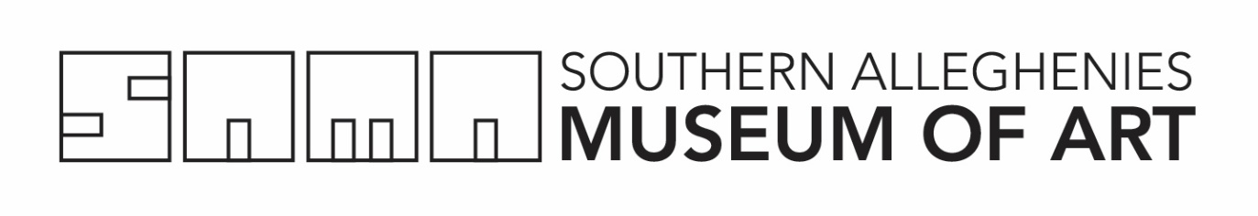
Checklist

Use the following checklist to make sure you have submitted everything that is required. All applicants MUST provide the following materials:

□ Residency Request Form* 1 copy
*Application form information must be completed in full and must contain all original signatures in ink.

□ Narrative Description of Project** 1 copy
**This description should address each of the points listed in the residency planning section below and must be answered on no more than two (2) 8 1/2 x 11 pages in total, single sided, using 10 or 12 point font. Responses must be typed or computer printed.

□ Residency Budget Worksheet 1 copy

Residency Narrative Description
Residency projects should be developed collaboratively with the artist(s), host site, and the Southern Alleghenies Museum of Art and must be signed by both the host organization and the artist(s). While project plans must be developed prior to application submission, it is understood that some “fine tuning” of the plans will occur between submission and the actual residency. This information will be used by SAMA to determine award amounts in the event funding is not sufficient to match the Host Site’s request.

□ Goals and Objectives: What do you want the participants to achieve as a result of this residency? How can the art form be integrated into various curricular areas? Consider arts-related goals as well as the PSSAs.

□ Core Group(s): Identify the number, ages and types of participants in the core group(s) and how the participants are selected. The core group(s) can be comprised of various grade levels but may not exceed three (3) groups of approximately 30 participants or fewer per group. The artist should meet with each Core Group each day of the residency.

□ Schedule of Events: Please include a sequence of events and/or activities. You may list a day-by-day schedule of a more general outline describing the beginning, middle and end of the residency.

□ Evidence of Participant Involvement in the Creative Process: Define the creative process and show clearly how Participants are involved directly in the process.

□ Teacher/Staff Involvement: What activities are planned to bring the artist(s) and teacher(s)/staff together? Describe activities such as staff in-service workshops including time/place/topic.

□ Other Participant Groups: Describe the activities affecting the wider scope of the site. Can the artist enrich the curriculum of participants other than the core group participants through exposure workshops? Include Introductory Assembly/Presentation.

□ Community Outreach: Describe activities that will reach the surrounding community. Possibilities include “Meet the Artist” Breakfast/Lunch at the site, Family Night exhibit or performance, exhibit or performance during open/visitation hours to which family and the community has been invited.

□ Facilities/Supplies: What facilities, materials, supplies, space, etc., will be made available for the residency? Include studio time and space for artist.

□ Additional Arts Resources: Describe additional resources that can be used to enhance the residency.

□ Evaluation/Follow Up: Describe how you will (a) extend the impact of the residency and (b) evaluate its effectiveness.

